HybridFEM MATLAB/Simulink Manual

The HybridFEM program runs under MATLAB and SIMULINK (R2007b and later) and is compatible with Target PC for real-time applications. It consists of a Structure, Elements and an Integrator for running the pseudo-dynamic simulation. The included Example System contains all the files necessary for running a local simulation using MATLAB and a real-time simulation using SIMULINK and xPC.

Inside the base code
The HybridFEM program consists of many MATLAB M-files and a MDL Simulink library file. It is also packaged with two examples under the Systems folder.
- CalculateMatrices.m: Forms the integration matrices.
- CreateElement_TypeN.m: Creates each type of Element object.
- CreateIntegrator.m: Creates the (CR) Integrator object.
- CreateMaterial.m: Creates the Material object inside an Element.
- CreateNode.m: Creates a single Node object with coordinates.
- CreateStructure.m: Creates a Structure object.
- FormElementMatrices_TypeN.m: Forms the Element matrices per type.
- GenerateCommands.m Generates the Command vectors (only for the LocalSimulator).
- GetEQHistory.m Loads the earthquake acceleration record.
- GetRestoringForce_TypeN.m: Calculates the restoring force for that element (only for the LocalSimulator).
- InitializeIntegrator.m: Initializes the memory used for the integration algorithm.
- LoadConfiguration.m: Reads the INP configuration file and sets up the Structure, Element and Integrator objects.
- UpdateAcceleration. Updates the acceleration vector and gets the next time step effective force (only for the LocalSimulator).
- HybridFEMLibrary.mdl Contains all of the required SIMULINK blocks for developing a Real-time model.

Input File Format
The HybridFEM program utilizes a configuration file which contains the structure, element and node information. The following is a non-functional example of the input file and below that is an explanation of the format.

- UNITS: KN-m-sec
- STRUCTURE DATA BLOCK
- NN NE NM NDIM NEN NDN ND NSLAVED
- 6 7 1 2 2 3 6 2
- NODAL COORDINATE DATA BLOCK
- NODE X Y Z UX UY THETA
- 1 0 6 0 1 2 3
- 2 6 6 0 1 4 5
- 3 0 3 0 6 7 8
- 4 6 3 0 6 9 10
- …
- MATERIAL DATA BLOCK
- MATERIAL E
- 200000000.0
- ELEMENT TYPE AND CONNECTIVITY DATA BLOCK
- ELEM TYPE NODE1 NODE2 {Element Properties}
- 1 1 1 2 …
- 2 2 3 4 …
- HYBRID TESTING DATA BLOCK
- T1 T2 KSI SF DT
- 1.4 0.41 0.03 1 0.009765625

Line 1: Metadata which defines the units that the system will be used. This line is not processed by the program.
Lines 2-4: Definition of the structure.
NN = Number of Nodes
NE = Number of Elements
NM = Number of Materials
NDIM = Number of Dimensions
NEN = Number of Nodes per Element (always 2)
NDN = Number of Degrees of Freedom per Node
ND = Number of Restrained Degrees of Freedom
NSLAVED = Number of Slaved Degrees of Freedom
Lines 5-11: Definition of the nodes and the indexes of the degrees of freedom.
NODE = Node ID
X = X coordinate
Y = Y coordinate
Z = Z coordinate
UX = DOF index for x-direction motion
UY = DOF index for y-direction motion
THETA = DOF index for rotation
Lines 12-14: Definition of the material data block
MATERIAL = Material ID
E = Modulus of Elasticity
Lines 15-18: Definition of the Elements and connectivity of elements
ELEM = Element ID
TYPE = Element type
NODE1 = ID of Node 1
NODE2 = ID of Node 2
{ELEMENT PROPERTIES} = Properties for each element depending on type
Lines 19-21: Definition of the hybrid testing properties
T1, T2 = Periods of the structure
KSI = Damping Ratio
SF = Earthquake record scaling factor
DT = Integration timestep

Element Types
- Elastic beam column element
Properties:
  - Material ID
  - Area
  - Inertia
  - Element Distributed Load
  - Damping Stiffness Factor
  - Damping Mass Factor
- Experimental link element with initial stiffness
Properties:
  - Initial Stiffness
  - Damping Stiffness Factor
  - Damping Mass Factor
  - Experimental Damping Factor
- Hinge (concentrated plasticity) beam column element (drain2dx type 2)
Properties:
  - Material ID
  - Area
  - Inertia
  - Element Distributed Load
  - Hardness
  - Av?
  - v?
  - Mpl?
  - Npl?
  - Damping Stiffness Factor
  - Damping Mass Factor
- Two-story gravity column
Properties:
  - K11?
  - K12?
  - K21?
  - K22?
  - m1?
  - m2?
  - Damping Stiffness Factor
  - Damping Mass Factor

Local Simulation
The HybridFEM program consists of an M-file for running local simulations within MATLAB. In the Example System, the file, “LocalSimulator.m” contains the code to run the local simulation. The user must edit the file first and set the input configuration file and the earthquake history file. Running this file will produce a plot of the displacement and restoring force results.

Real-time Simulation
The HybridFEM program has the capabilities of running models in real-time using SIMULINK and xPC. In the Example System, the file, “RealtimeModel_Setup.m” contains the code to set up the system and the file, “RealtimeModel.mdl” contains the SIMULINK blocks that run the integration algorithm and compute the restoring forces. The model is multi-threaded meaning that the integration time step is a multiple of the fundamental sample rate. This allows for actuator ramping at the fundamental sample rate which the complex integration algorithm performs its calculations over the full time step.

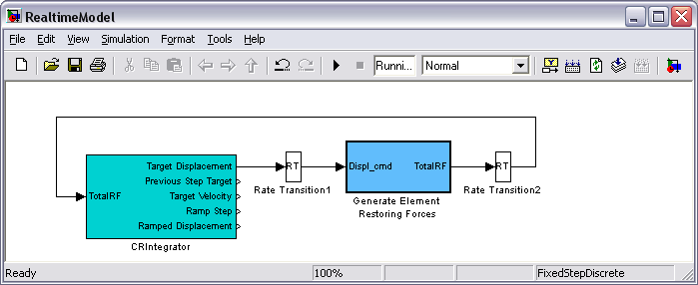

In the above system, the light blue block, “CRIntegrator” represents the CR Integration algorithm. It generates the displacement command and accepts the total restoring force as input. It connects to the “Generate Element Restoring Forces” block which performs the per element restoring force calculations. The “Rate Transition” blocks are necessary to bridge the multi-tasking architecture since the “CRIntegrator” block runs at the fundamental sample rate and the “Generate Element Restoring Forces” block runs at the integration time step.

To interface with this model, the user can connect to either the “Target Displacement” or “Ramped Displacement” output from the “CRIntegrator” block. The “Target Displacement” output is the displacement command generated at every integration time step and the “Ramped Displacement” is the same single run through a linear interpolator at the fundamental sampling rate. Below are the subsystem components of the “Generate Element Restoring Forces” block.

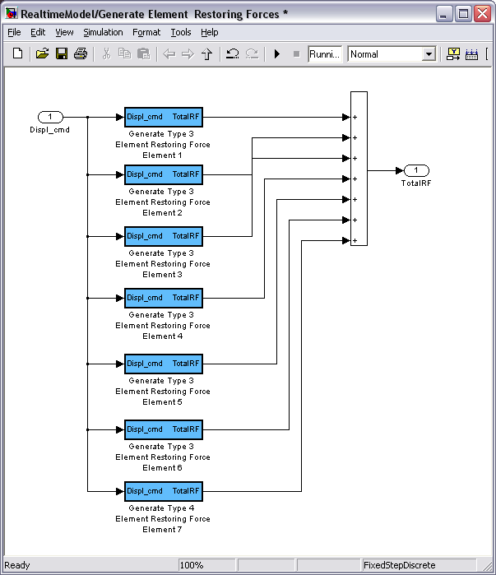

Each element block takes the displacement command from the Integrator as an input and produces a restoring force. Element type 2 has an extra input for using an experimental restoring force instead of generating it internally. Each element restoring force output must then be summated and returned to the Integrator as a total restoring force input. Below is an example of a real-word system utilizing type 2 elements and SCRAMNet.

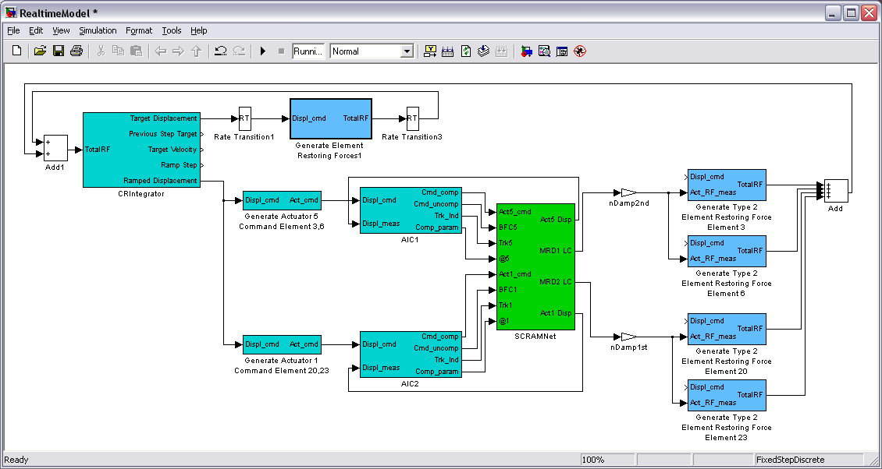

In this model, the “Ramped Displacement” output is used as an input to the “Generate Actuator n Command” blocks since there are two actuators being used. The actuator command generated from this block is used as input to the AIC block which also has the measured displacement of the actuator as an input. The green block interfaces with SCRAMNet to send commands and gather feedback from the control system. The restoring force of the experimental elements is used as the “Act_RF_meas” input of the Type 2 Elements. Finally, all “TotalRF” signals are summated and used as the input for the integrator.

